**KUBERNETES ON GOOGLE**

**BEFORE YOU BEGIN**

hxxps://cloud.google.com/sdk/docs/quickstart-windows

1. [Create a Google Cloud Platform project](https://console.cloud.google.com/cloud-resource-manager?_ga=2.56202478.-499371466.1559793331&_gac=1.187633882.1563845118.Cj0KCQjwvdXpBRCoARIsAMJSKqLxAgkY9ZQF5LGr-NLenP1DeKvwVTcEf2CpKGn71U4vSjYuDiBxTQMaAhoAEALw_wcB), in this example, the project named **k8s-project.**
2. Download the [Google Cloud SDK installer.](https://dl.google.com/dl/cloudsdk/channels/rapid/GoogleCloudSDKInstaller.exe)
3. Launch the installer and follow the prompts. After installation has completed, the installer presents several options, make sure that the following are selected:

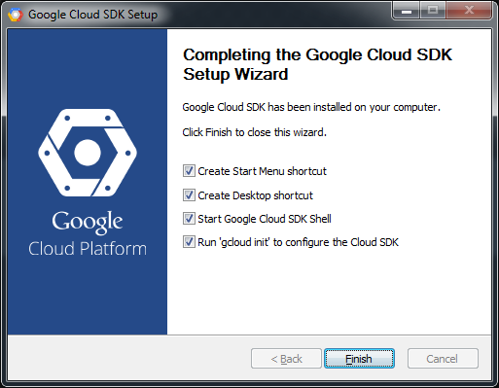

1. The installer then starts a terminal window and runs the gcloud init command.

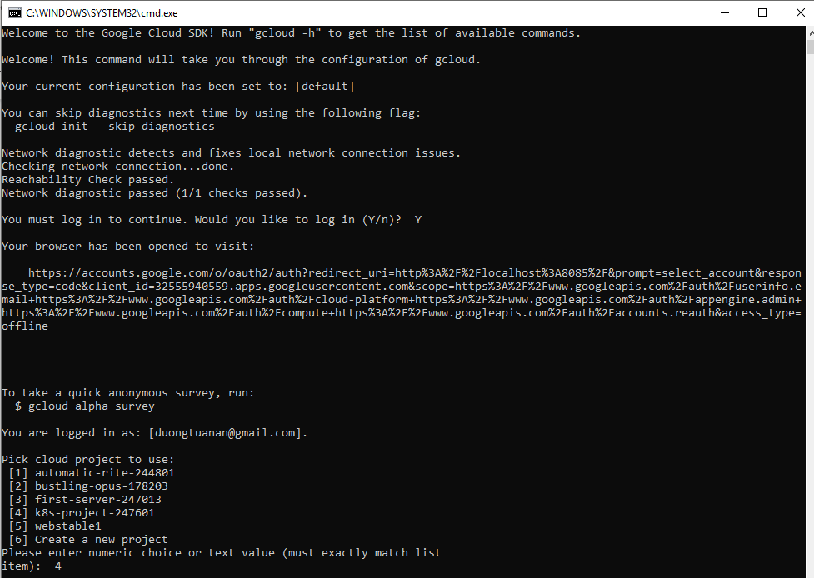

1. Navigate to web console> K8S project > Compute Engine> Settings. Change **region** and **zone** to which one you want to use.

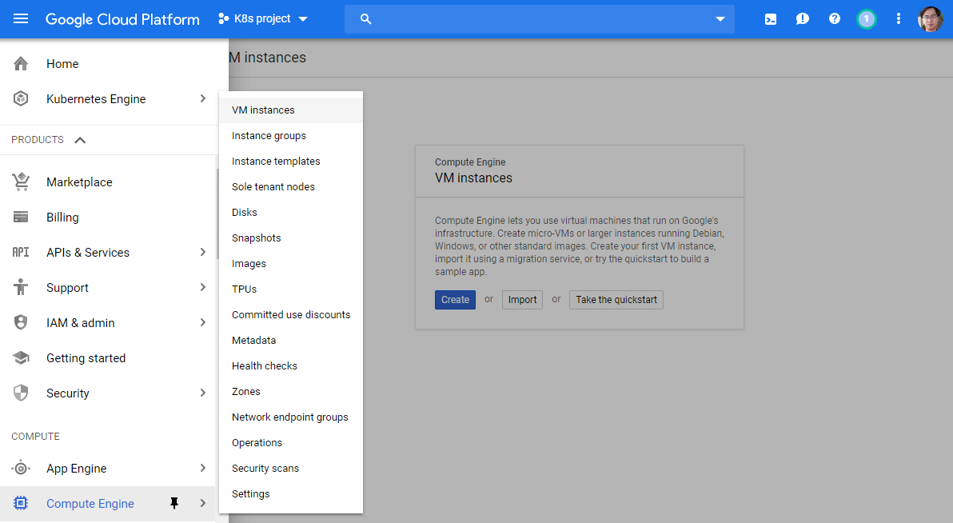

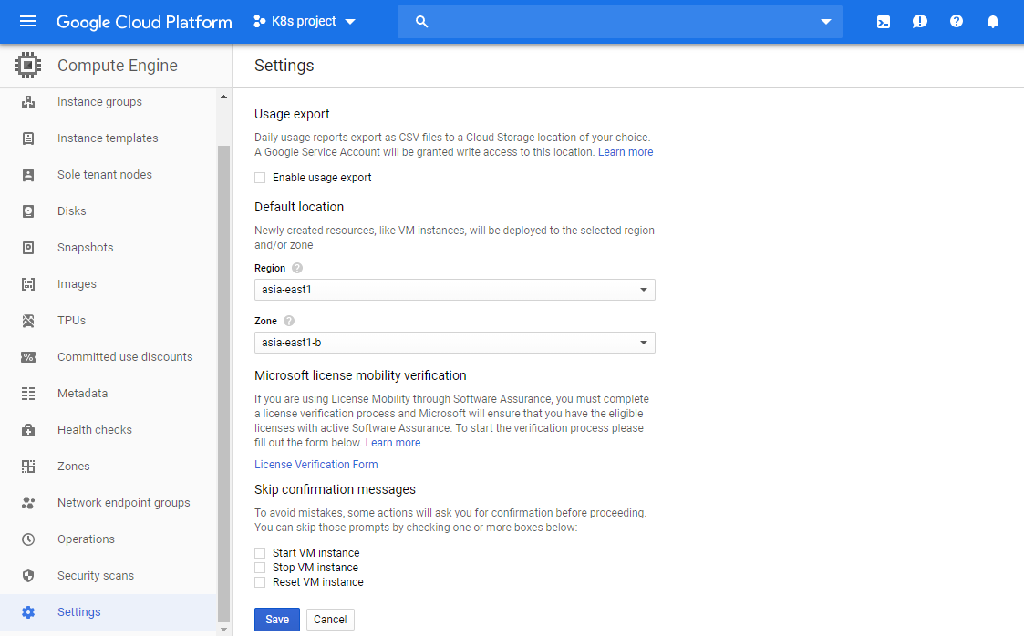

1. Back to CMD console, type the following command to check.

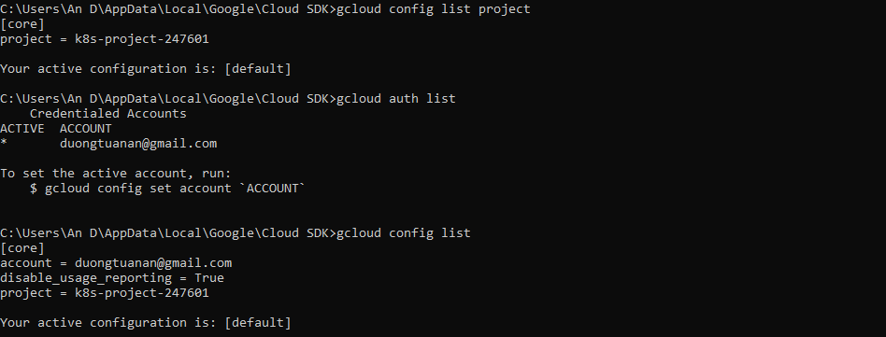

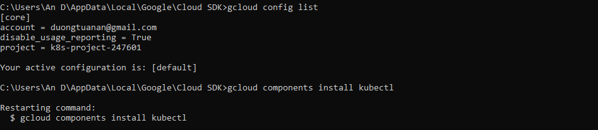

**CREATE CLUSTER**

Open web console, K8S project> Kubernetes Engine> Create cluster and follow the wizard to comple:

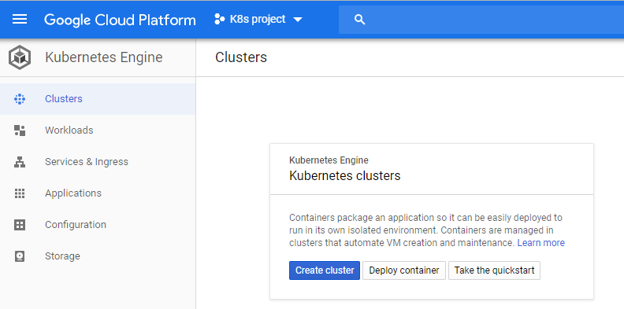

After created the cluster, click cluster name, click **Connect**

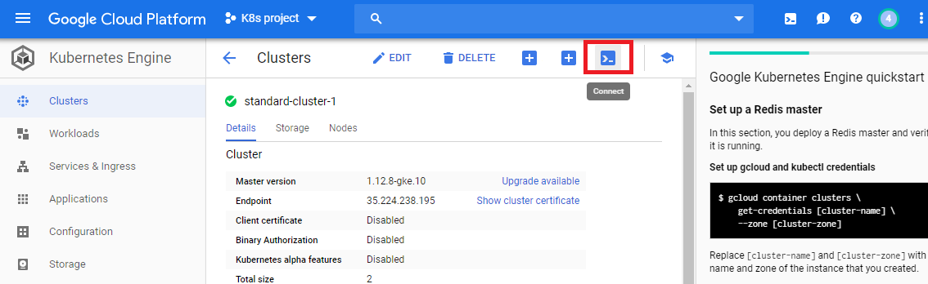

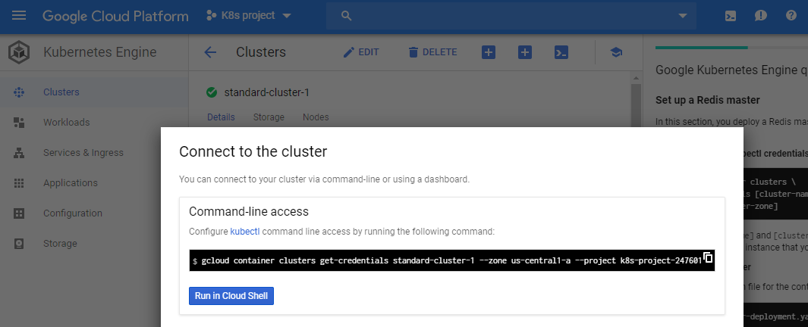

Paste the command-line to connect cluster, then you’re now feel free to use **kubeclt**

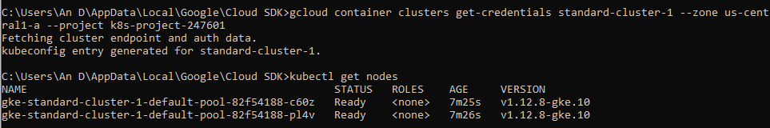

**DEPLOY THE FIRST APP**

Create deployment.yaml

apiVersion: apps/v1

kind: Deployment

metadata:

name: nginx-deployment

labels:

app: nginx-deployment

spec:

replicas: 2

selector:

matchLabels:

app: nginxa # for later use with NodePort

template:

metadata:

labels:

app: nginxa # for later use with NodePort

spec:

containers:

- name: nginx

image: nginx:1.7.9

ports:

- containerPort: 80

Deploy to cluster

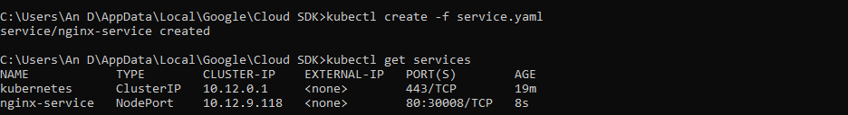

Create service.yaml for external access

apiVersion: v1

kind: Service

metadata:

name: nginx-service

spec:

type: LoadBalancer

ports:

- port: 80

selector:

app: nginxa

Deploy to cluster

